Needs Statement:

While on the move, the use of small devices such as flashlights and camera can take up a hand that would otherwise be free to focus on the task the user is pursuing. A device that provides various functions such as these, while allowing the user to remain hands-free, is required. There are weight limitations that must be satisfied in order for the drone to maintain proper function, and a certain amount of desired battery life that should be achieved, and will be taken into account when manipulating the weight of the drone.

Objectives Statement:

The objective of this project is to create a small drone capable of automatically following the user while performing various functions such as illuminating its immediate area with light. Utilizing inexpensive components, the team will create an autonomous, obstacle-avoiding drone with these capabilities. The design will have an operating life of at least 30 continuous minutes before requiring charge. It will also utilize infrared sensors to maintain a close (~18 inches) following distance to the user.

Background:

Drones are versatile, and contain microcontrollers capable of providing a variety of peripheral functions to a user. Although there are other solutions to the problem of having the use of small electronics take up one or both of a user’s hands, an autonomous drone has the potential to perform these functions better thanks to a larger battery, a remote perspective, and the lack of need for input from the user. Autonomous, “follow-me” drones have already gone to market, but there are few models, and those in production utilize GPS, which is relatively inaccurate for position location. In addition, these models do not possess the versatility that the team plans to incorporate into their design.

Marketing Requirements:

* Affordable – minimize price.
* Battery life – drone should be able to operate for a minimum of two hours.
* Speed – drone must be able to keep pace with a person on a bicycle.
* Functionality – drone must provide multiple functions to the user.
* Accurate – drone should be able to maintain a close following distance.
* Safety – drone will maintain safe distance from user, and will avoid obstacles so as to not to collide with objects or people.
* Regulations – drone will be compliant will any and all current drone regulations, including maximum allowed height and restricted airspace regulations.

Objective Tree:

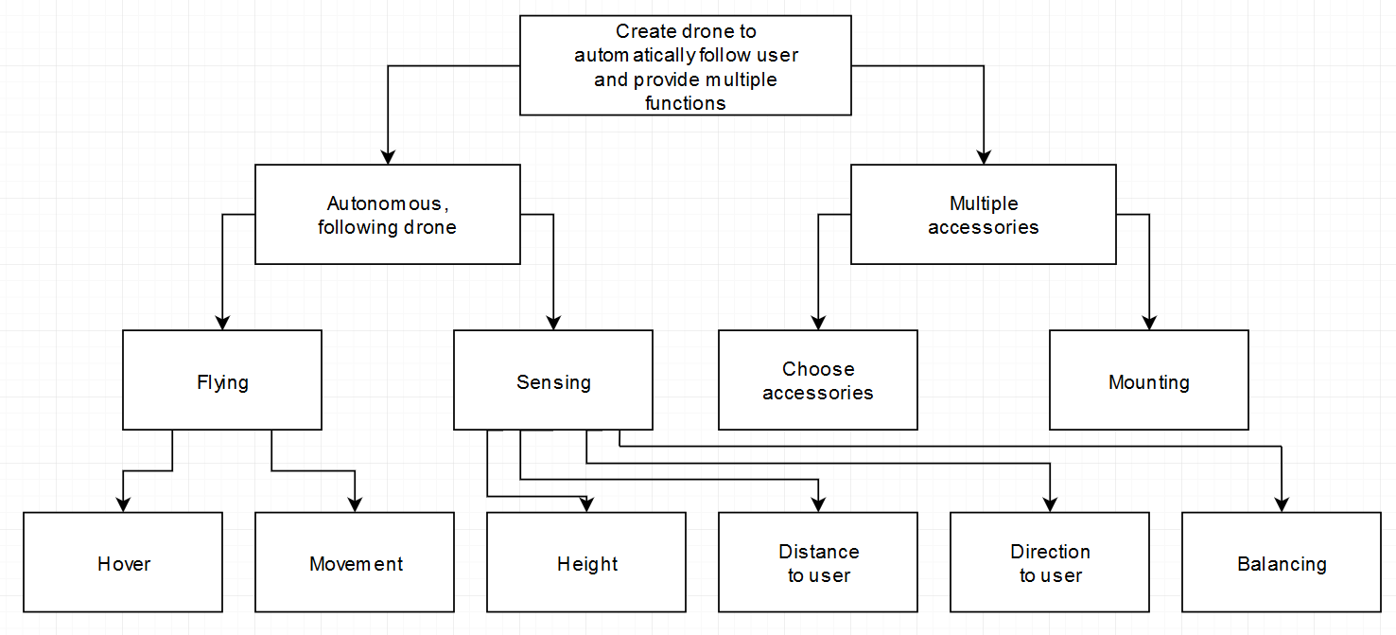

**Requirements Statement**

|  |  |  |
| --- | --- | --- |
| Marketing Requirements | Engineering Requirements | Justification |
| 1 | Should be able to run 3-6V motors at an average of 600mA for approximately 30 minutes. | This is a realistic duration of time, giving the user plenty of operation off a single charge. |
| 2, 3 | System will utilize IR and ultrasonic sensors to track the user while avoiding obstacles. | IR provides a more accurate method of determining the user’s location and distance, and ultrasonic sensors are ideal for obstacle detection. |
| 4 | System cost will not exceed $150. | Based on competitive market prices for similar product. |
| 2 | The system will maintain a following distance of approximately 18-36”. | This following distance is far enough to be safe for the user, and close enough to be safe for passers-by. |

Marketing Requirements:

1. System should last a reasonably long time.
2. System should be hands-free.
3. System should avoid obstacles.
4. System should be relatively low-cost.

**Tradeoff Matrices**

|  |  |  |  |  |  |
| --- | --- | --- | --- | --- | --- |
|  |  | **Output Power** | **Sensors** | **Following distance** | **Cost** |
|  |  | **+** | **+** | **+** | **-** |
| **Long-lasting** | **+** | ↓↓ | ↓ |  | ↓ |
| **Hands-free** | **+** |  | ↑↑ | ↑ | ↑ |
| **Avoids obstacles** | **+** |  | ↑↑ |  |  |
| **Cost** | **-** |  | ↓ |  | ↑↑ |

**House of Quality**

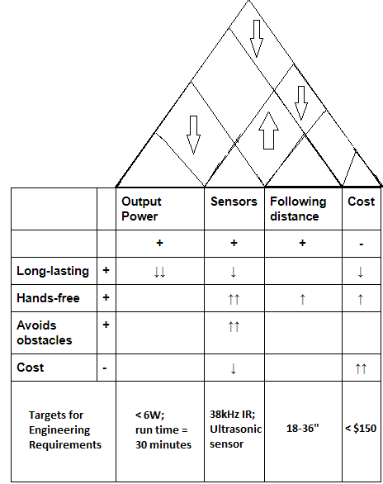

**Initial Design Concept**

The team’s initial design concept is a drone that acts both actively and passively using information gathered from various sensors. The drone will be a “follow-me” drone that utilizes an IR transmitter/receiver pair to accurately track the user. It will maintain a safe distance, slightly behind and above the user, and will feature an ultrasonic sensor to prevent obstacle collisions. The flight controller will be an Arduino Uno, and will interface with a small object, to be carried by the user, containing the IR transmitter. Additional peripheral functions (yet to be finalized) include LED displays, bright LED spotlights, and bluetooth speakers. The intention is for the drone to be versatile and reconfigurable enough to accommodate various peripheral functions.